
RSVision Centreboard Case Packing Instructions

The packing should be glued to the inner surface of the centreboard case, under the top capping in the position shown in the photograph below - one piece on each side of the centreboard case.

You will need:
Acetone or Thinners:
Rag
Glue Gun
Optional wedge(s) or clamps
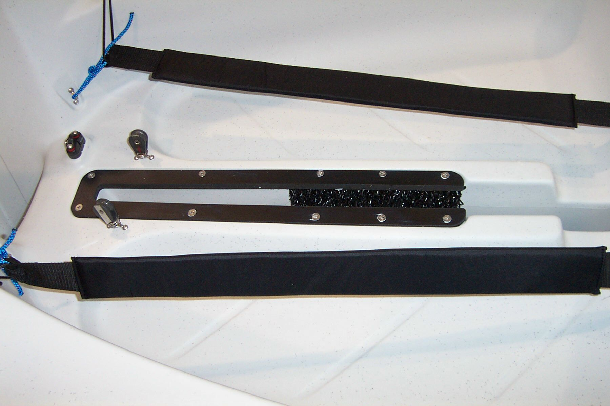
Instructions:
1) Clean the inside surface of the centreboard case using acetone or thinners.

2) Assemble the glue gun (as per instructions with the gun & glue).

3) Apply glue to the back of the packing piece.

4) Put the packing piece in position in the centreboard case. Optionally you could use a clamp or a wedge to ensure nothing moves whilst the glue is setting.

5) Leave the glue to set for approximately 5 hours.

