
RS Feva Stern Towing Strop
Fitting instructions.

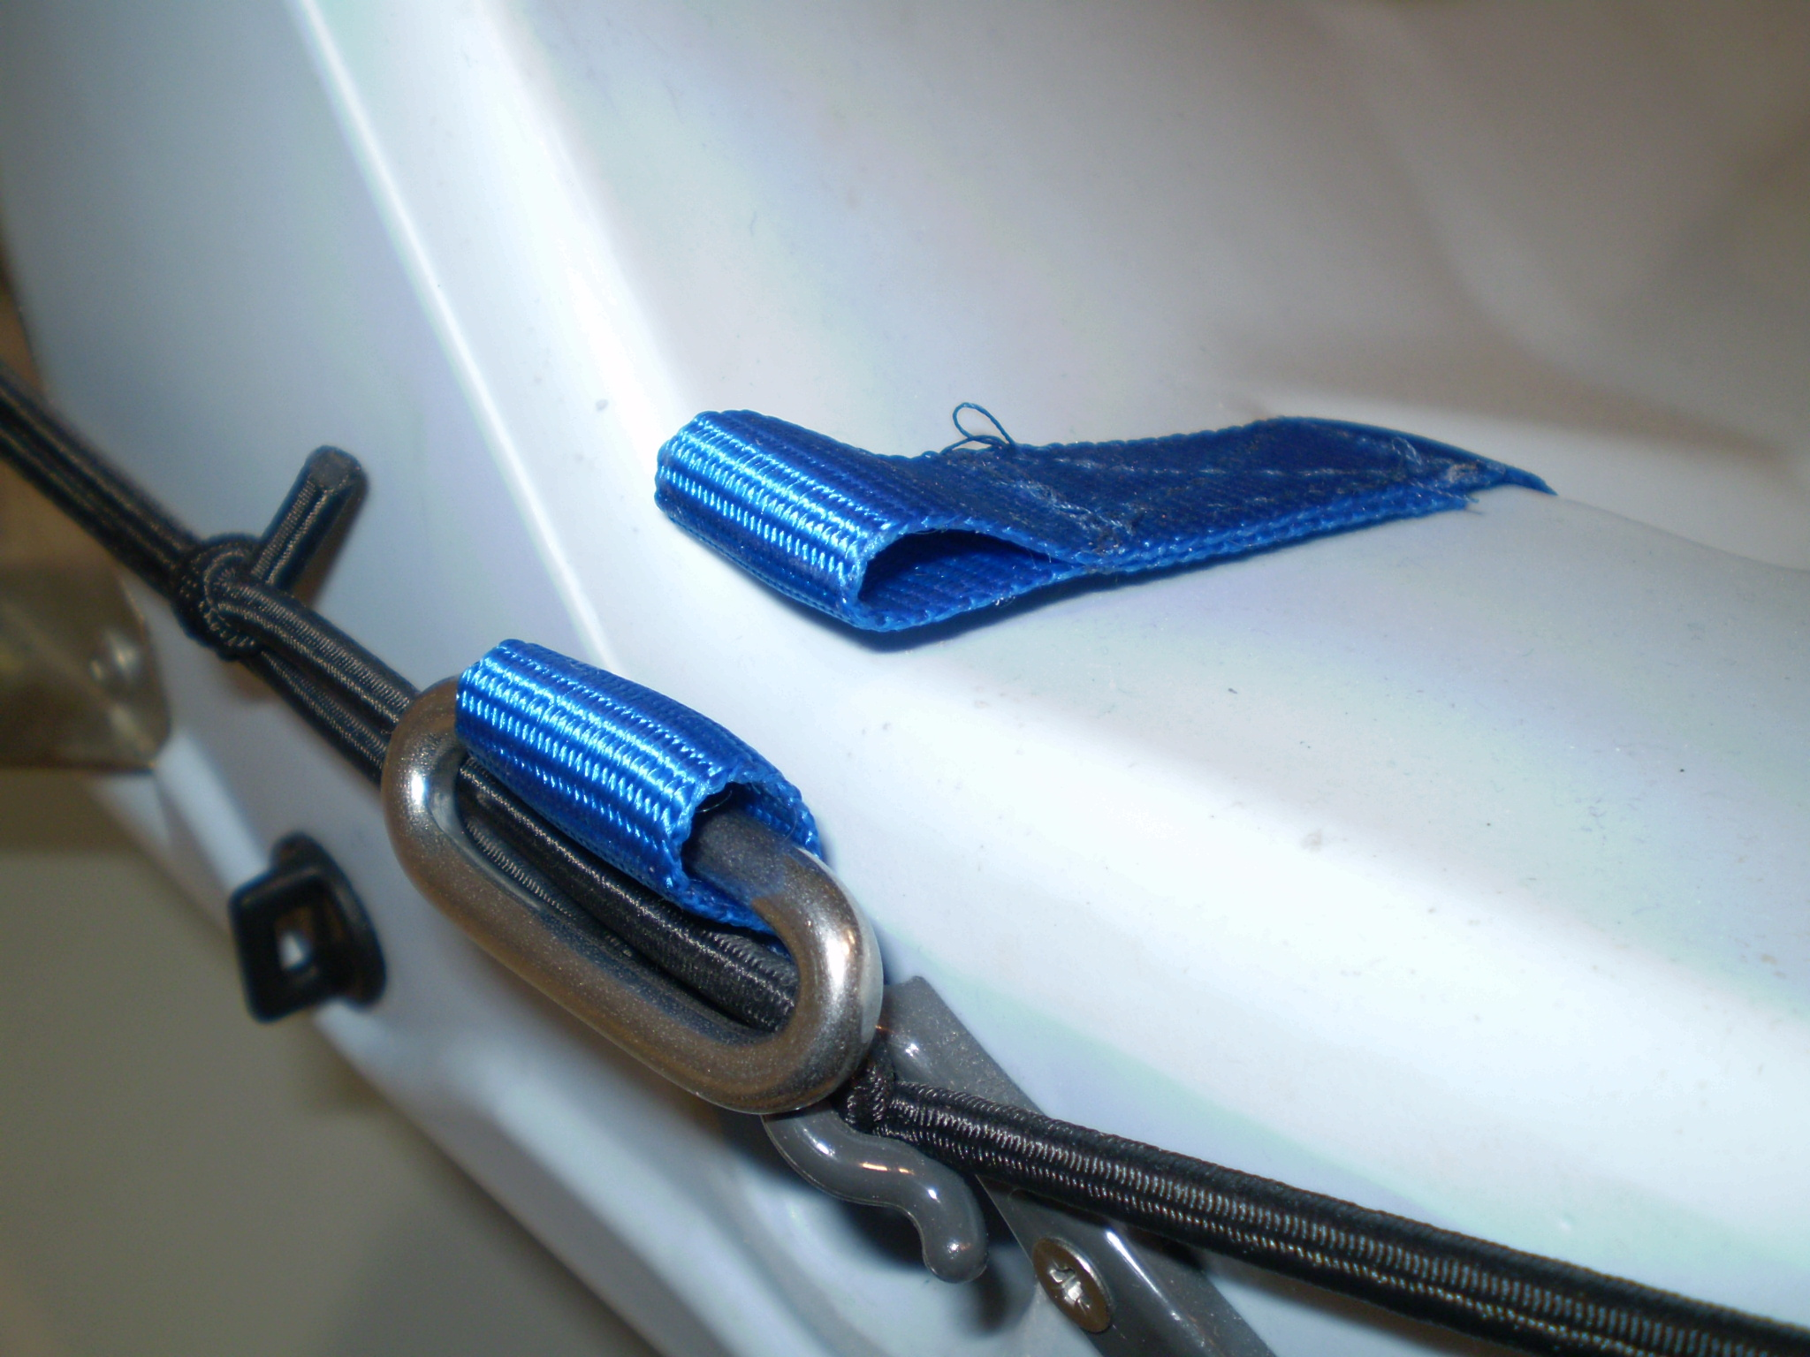
Having undone the shackle from the towing strop, pass it through either of the drainage channels from the transom forward and back over the top (see first picture)

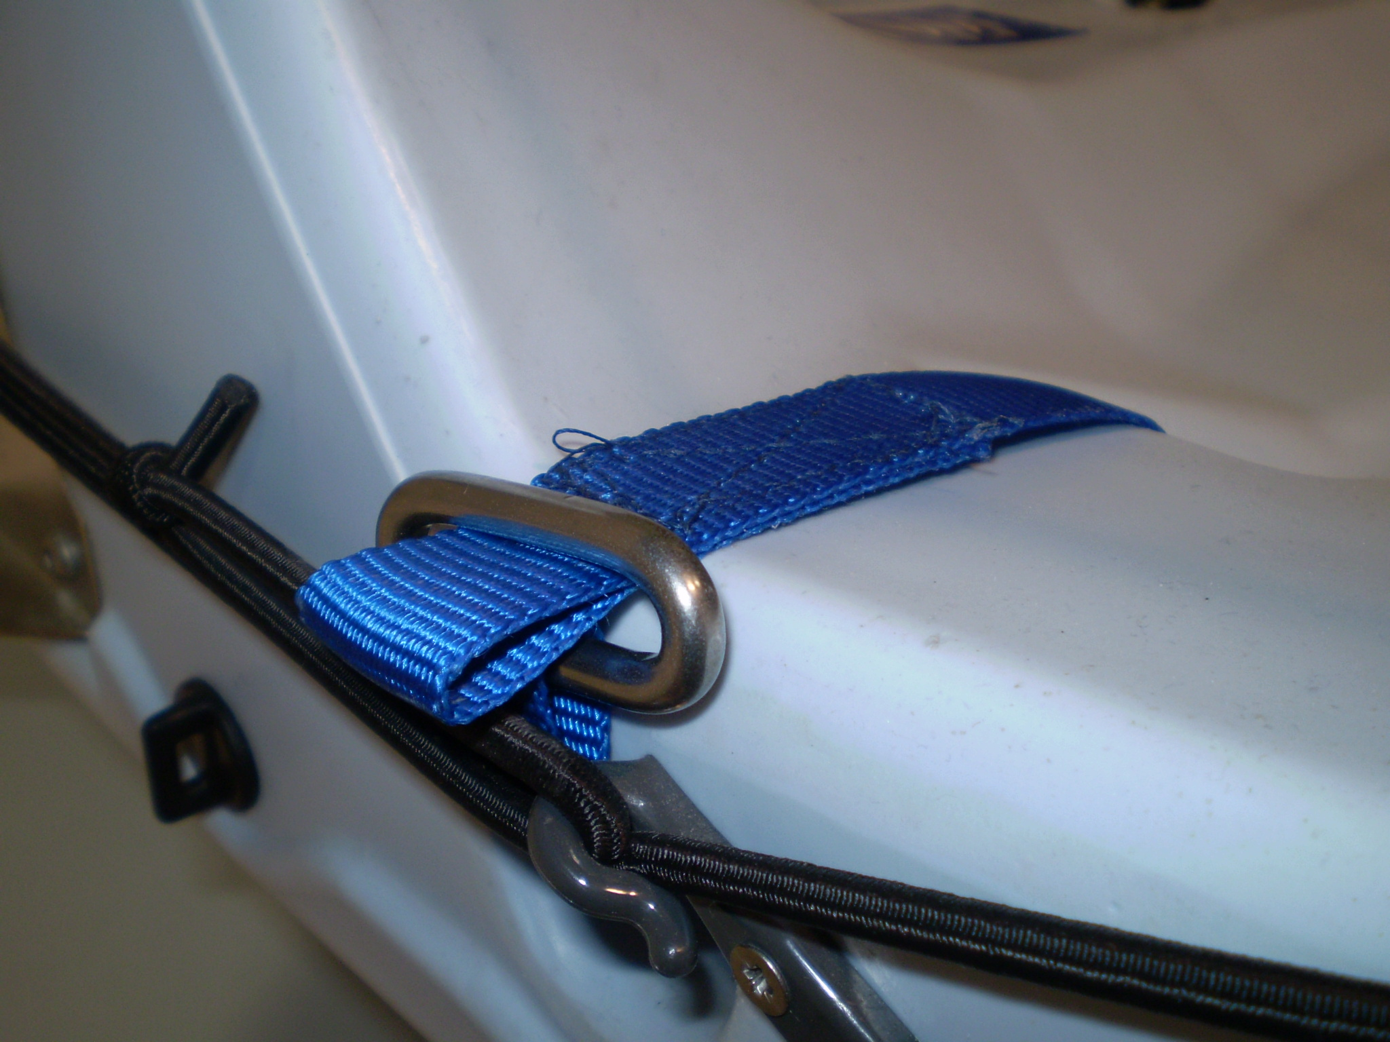
Pass the strop through the stainless plate making sure that the webbing is not twisted.

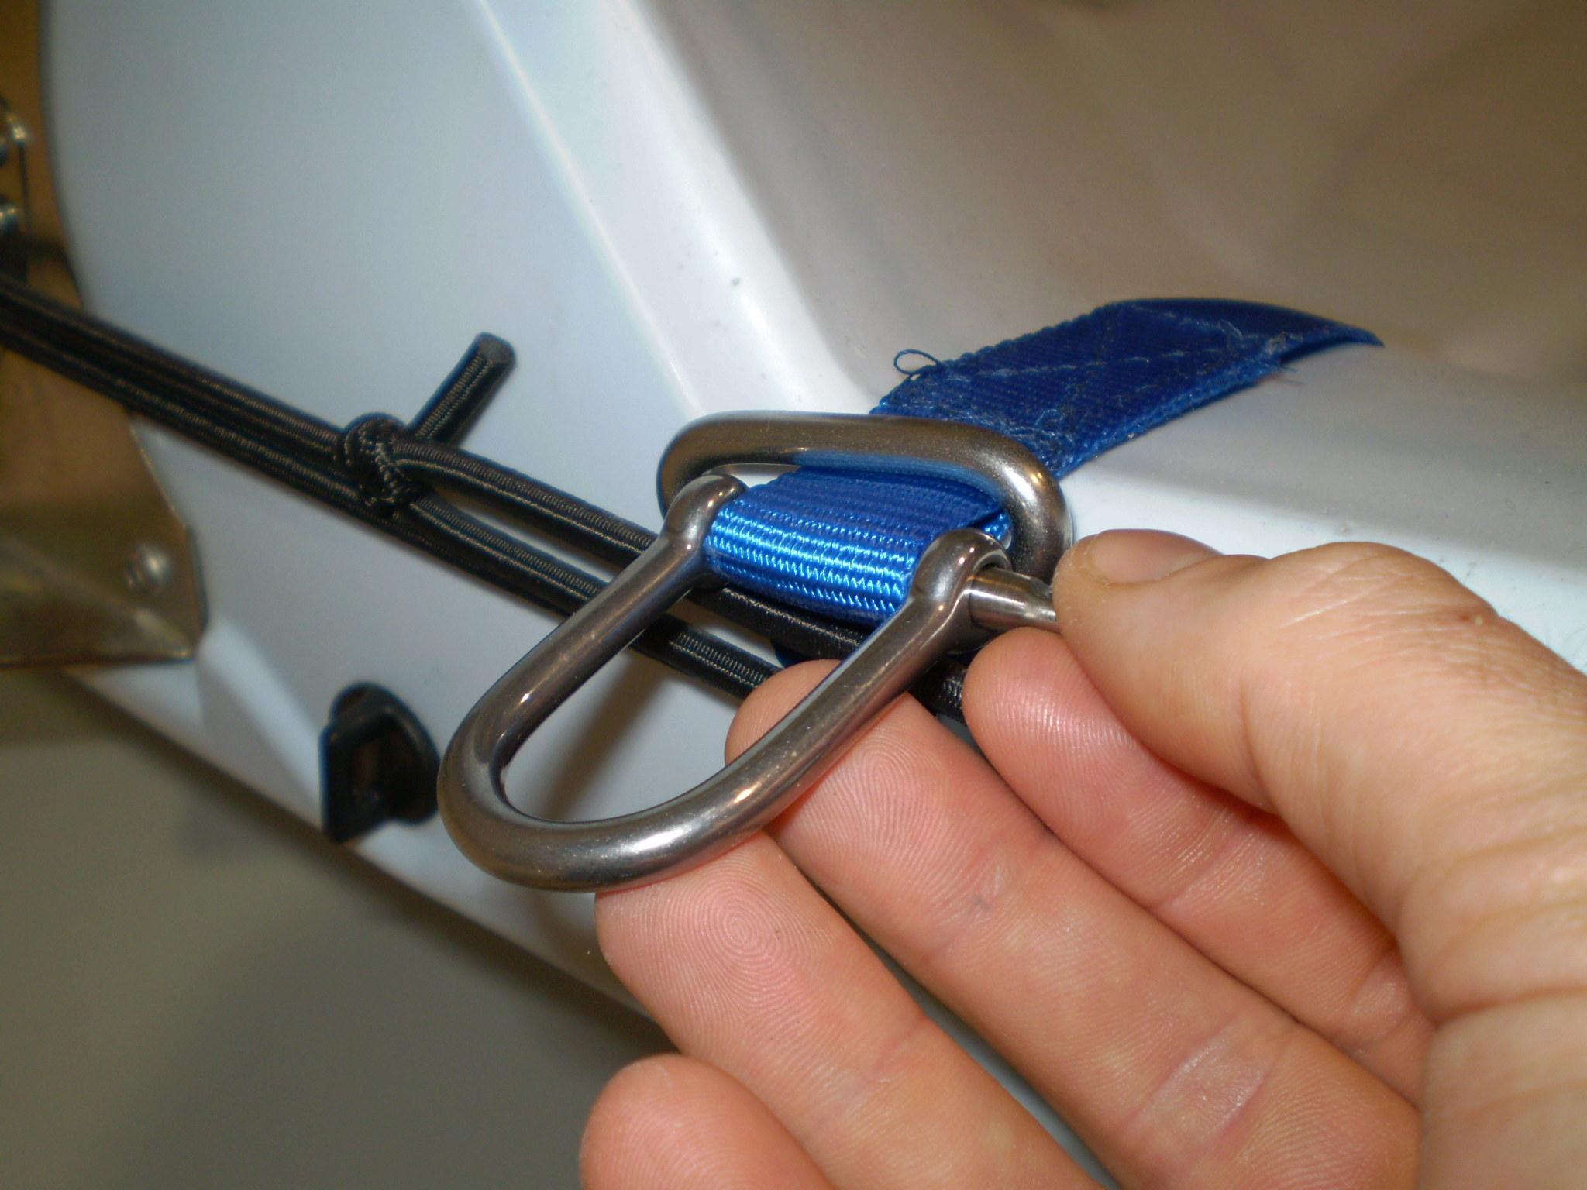
Attach the shackle.

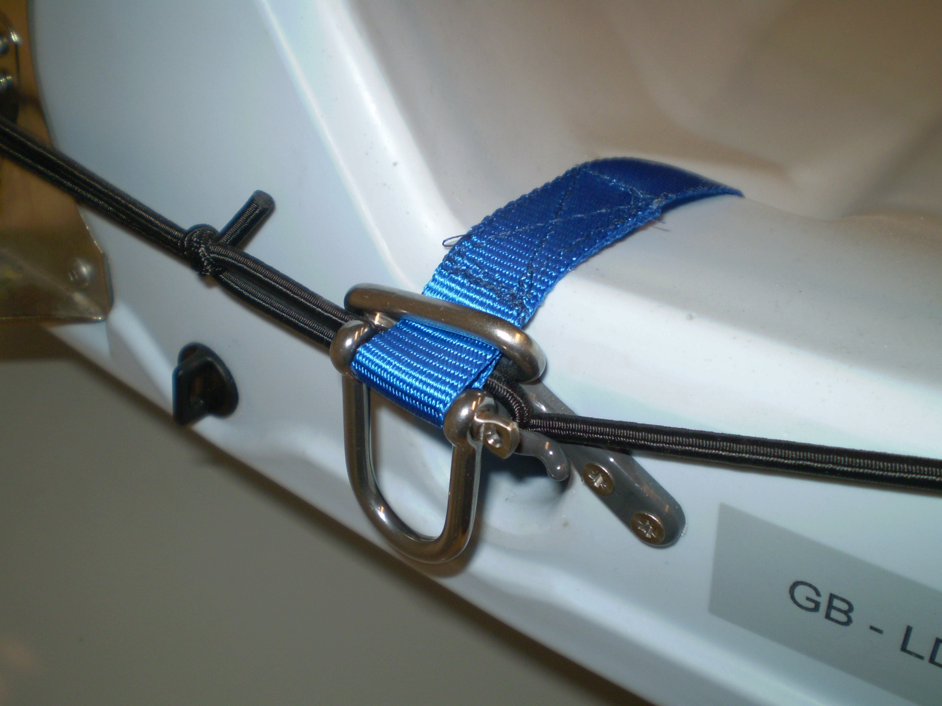
Make sure the shackle is done up as tight as possible. If you are in any doubt, use a small cable tie through the eyelet of the shackle to ensure it does not come undone.

Hang shackle over bungee so as not to foul righting line clip and the strop will be ready to use.

