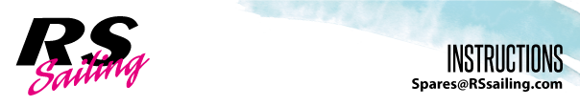
RS Vision Stern Towing System

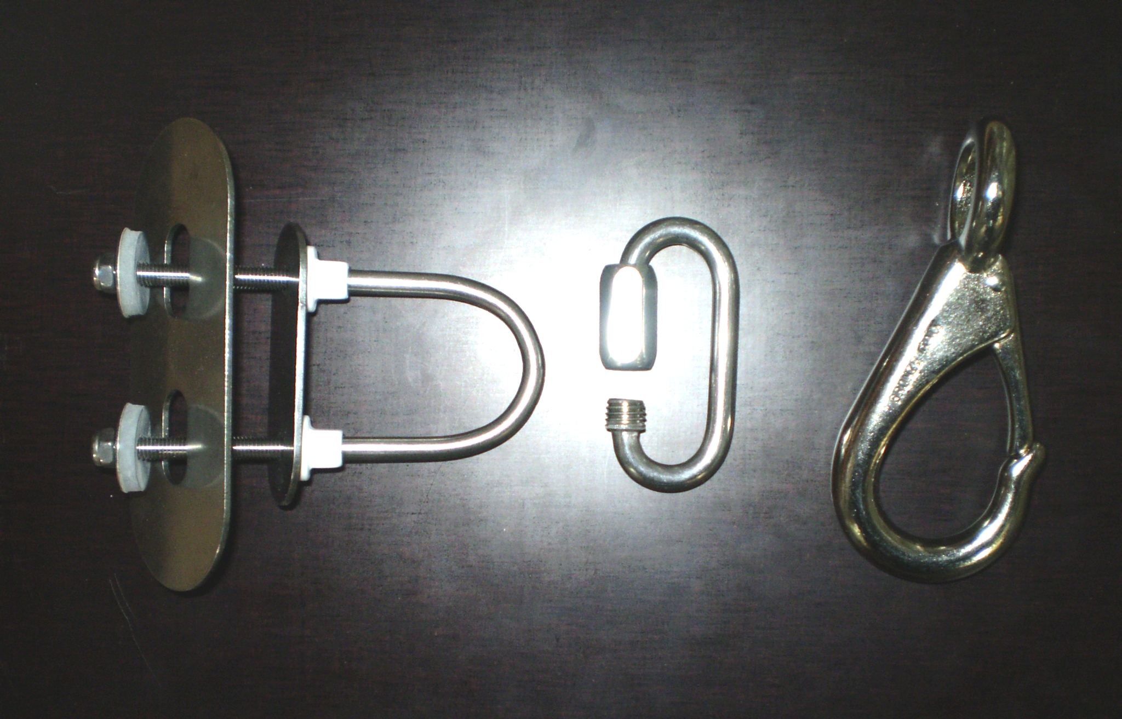
Parts included:
U-bolt (1)
White Plastic Threaded Stoppers (2)
Small Metal Backing Plate (1)
Large Metal Backing Plate (1)
Special Padded Washers (2)
8mm Nylock Nuts (2)
Stainless Rigging Link (1)
Bronze Naval Boat Snap (1)

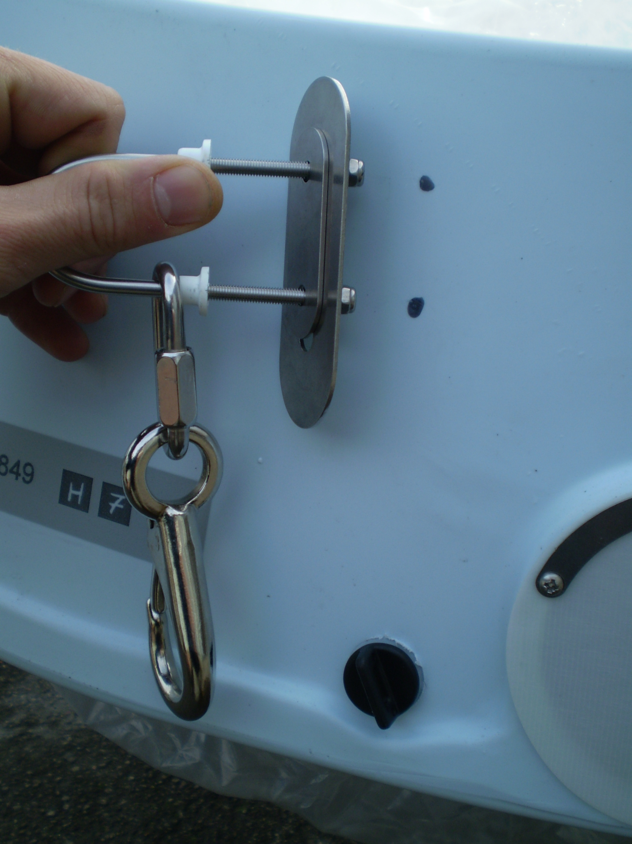
Place the whole system against the transom of the boat on the port side, with the U-bolt sitting vertically as in the picture.

Make sure that it is high enough for the Boat Snap not to hang below the bottom of the hull and, using a permanent pen, mark where the holes are to go.

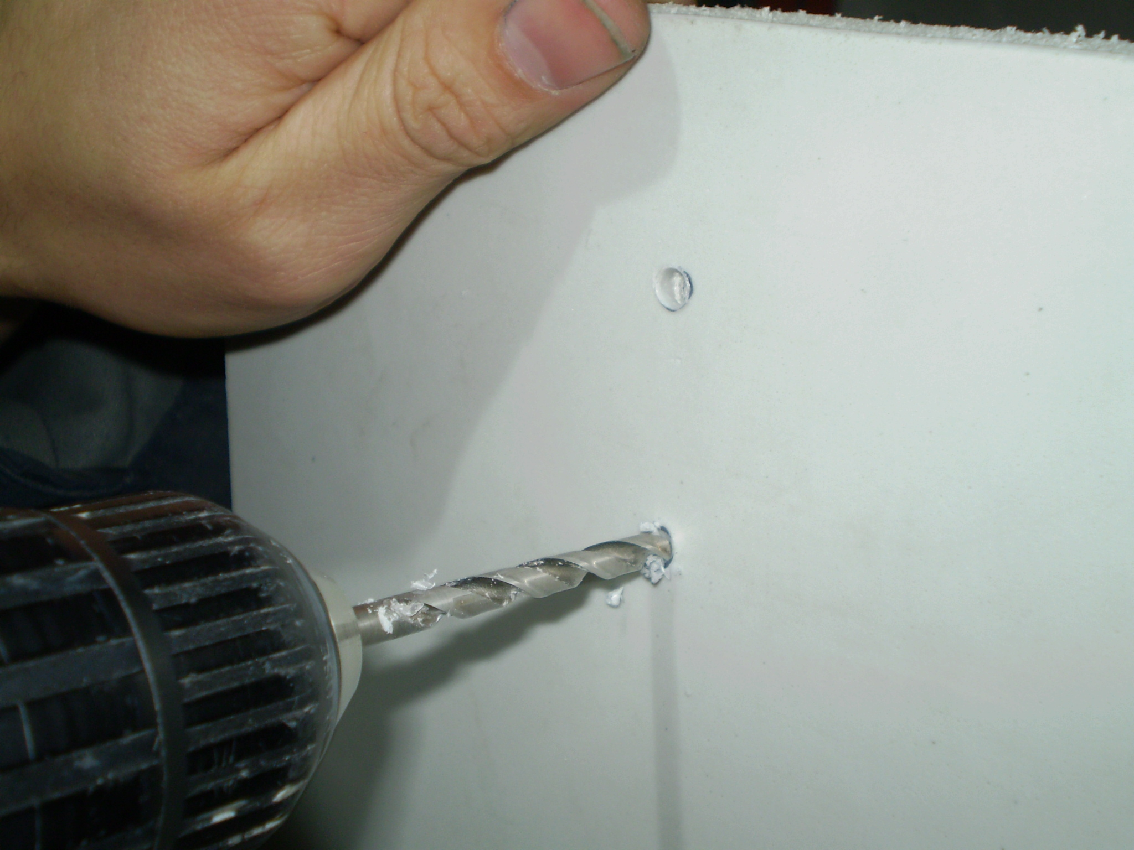

Drill out the two holes (using the marks as a guide) using a 5mm drill bit.
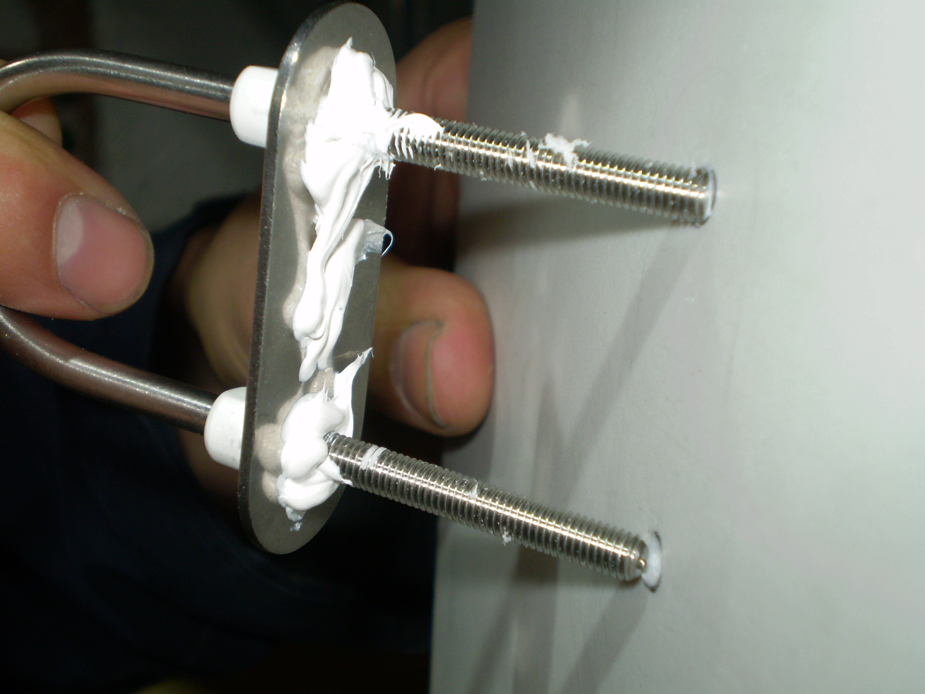

Using a marine sealant like Sikaflex or similar, apply to the underside of the small external backing plate in order to seal the holes you have drilled through the transom. This will seal the holes once the plate is fixed in place.
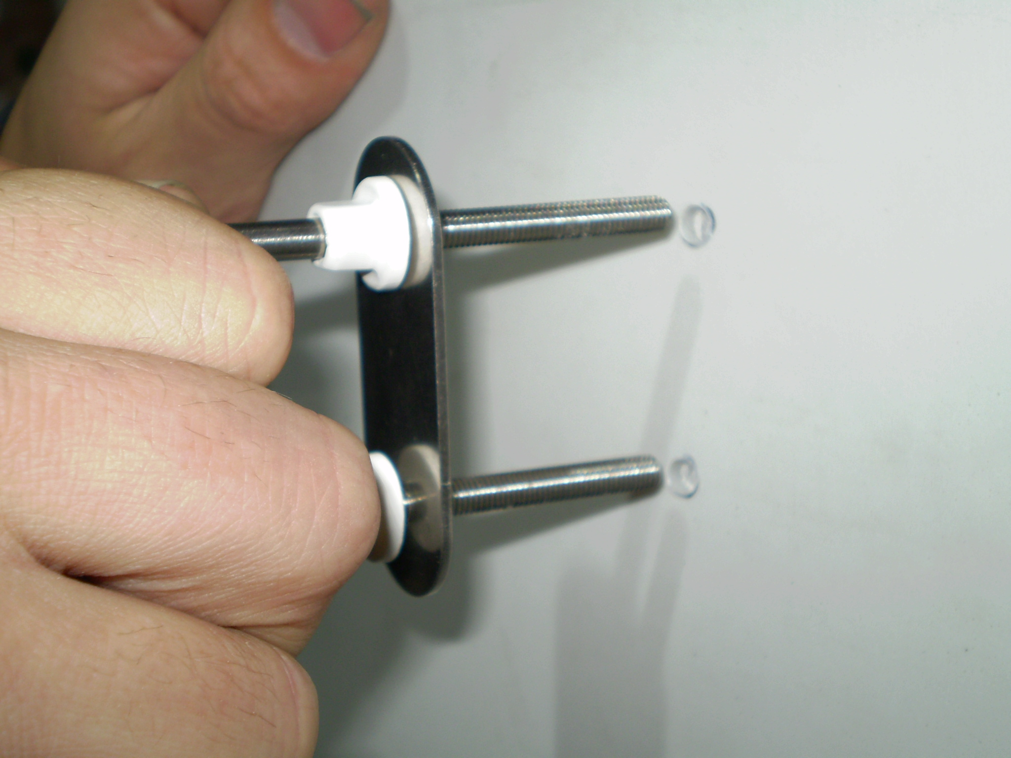
Push U-bolt assembly through the holes

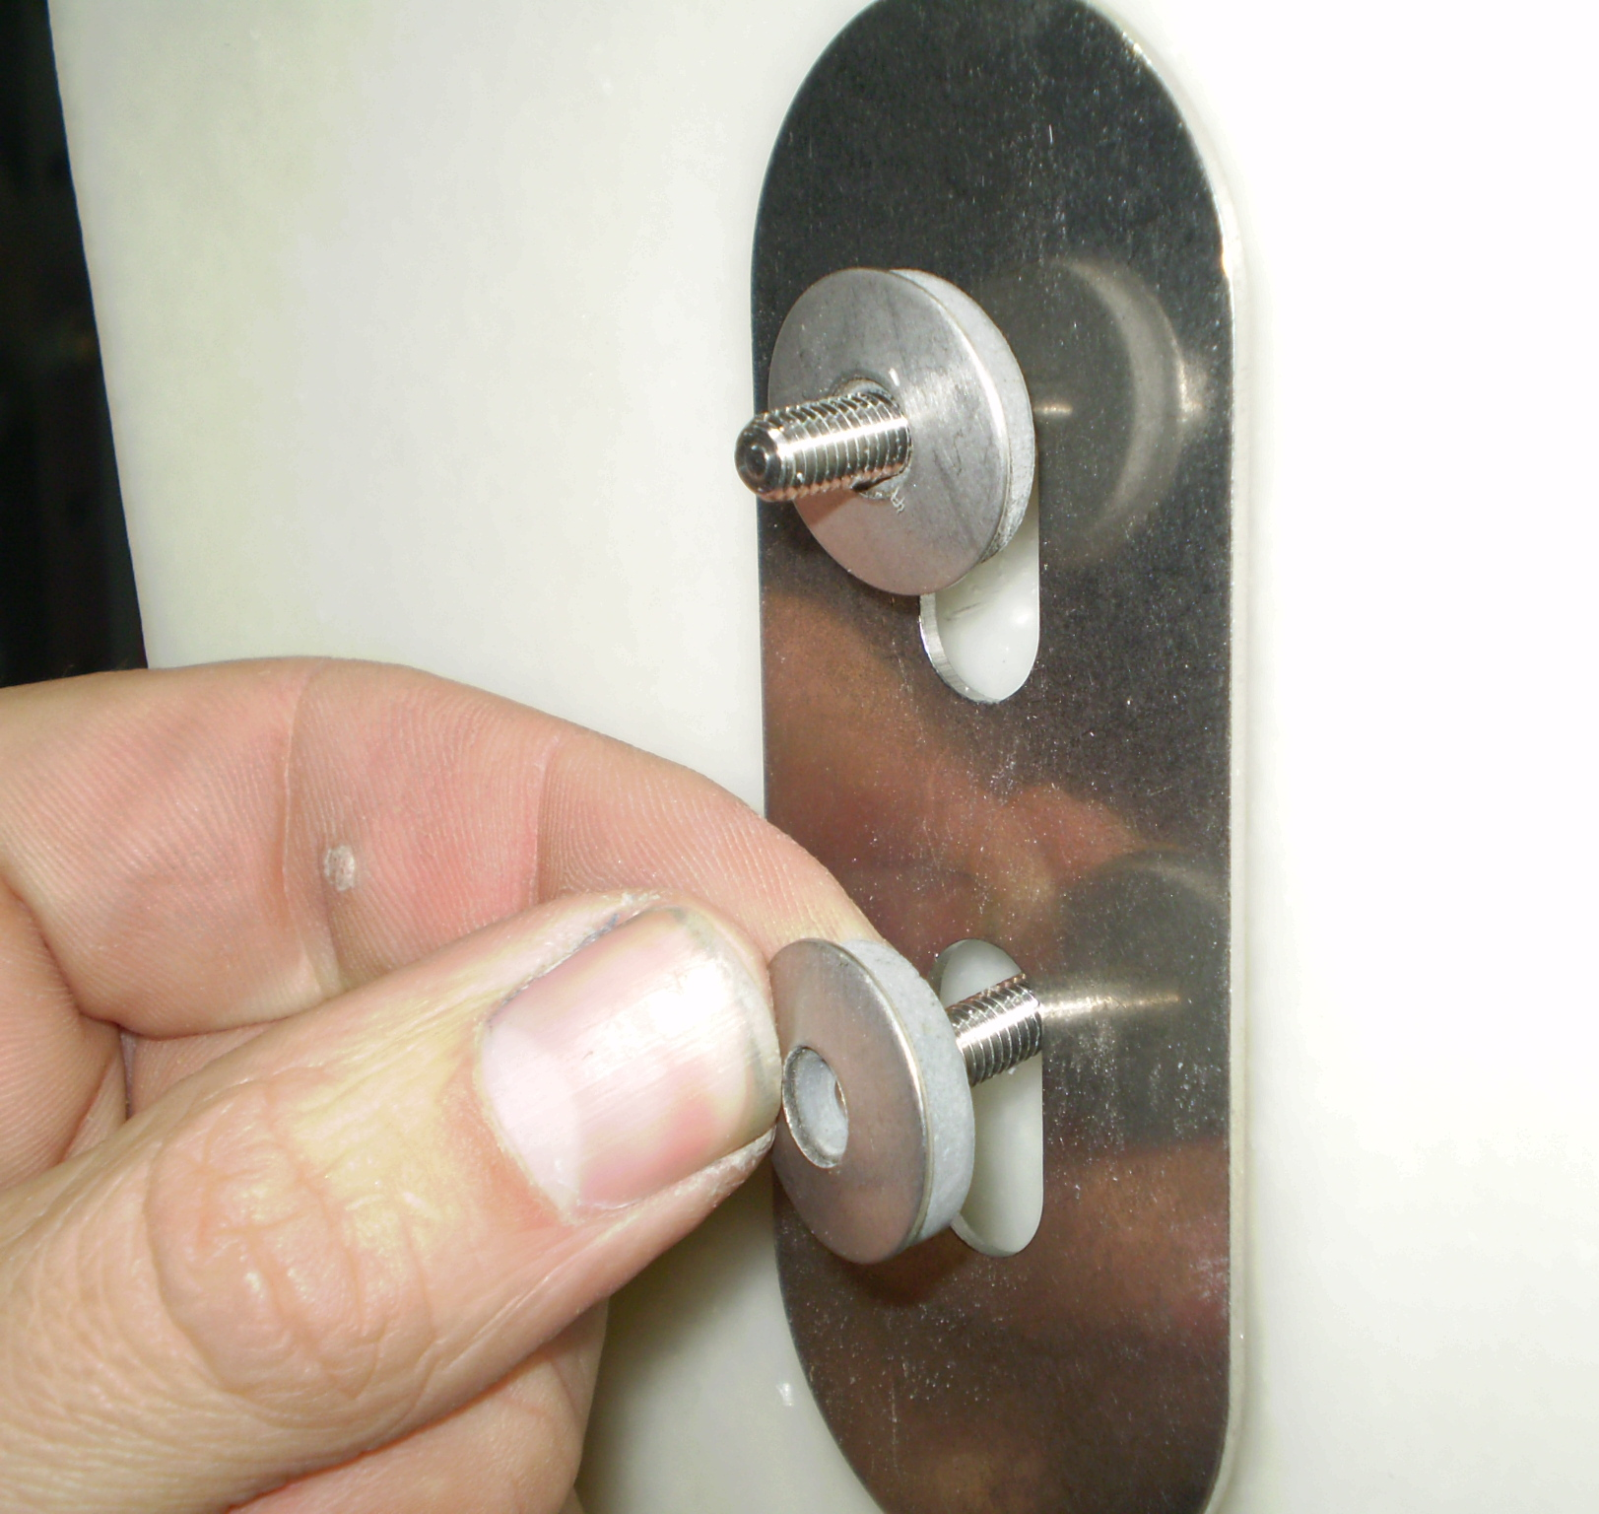

Add the larger backing plate and the special washers with the soft rubber side towards the metal backing plate.

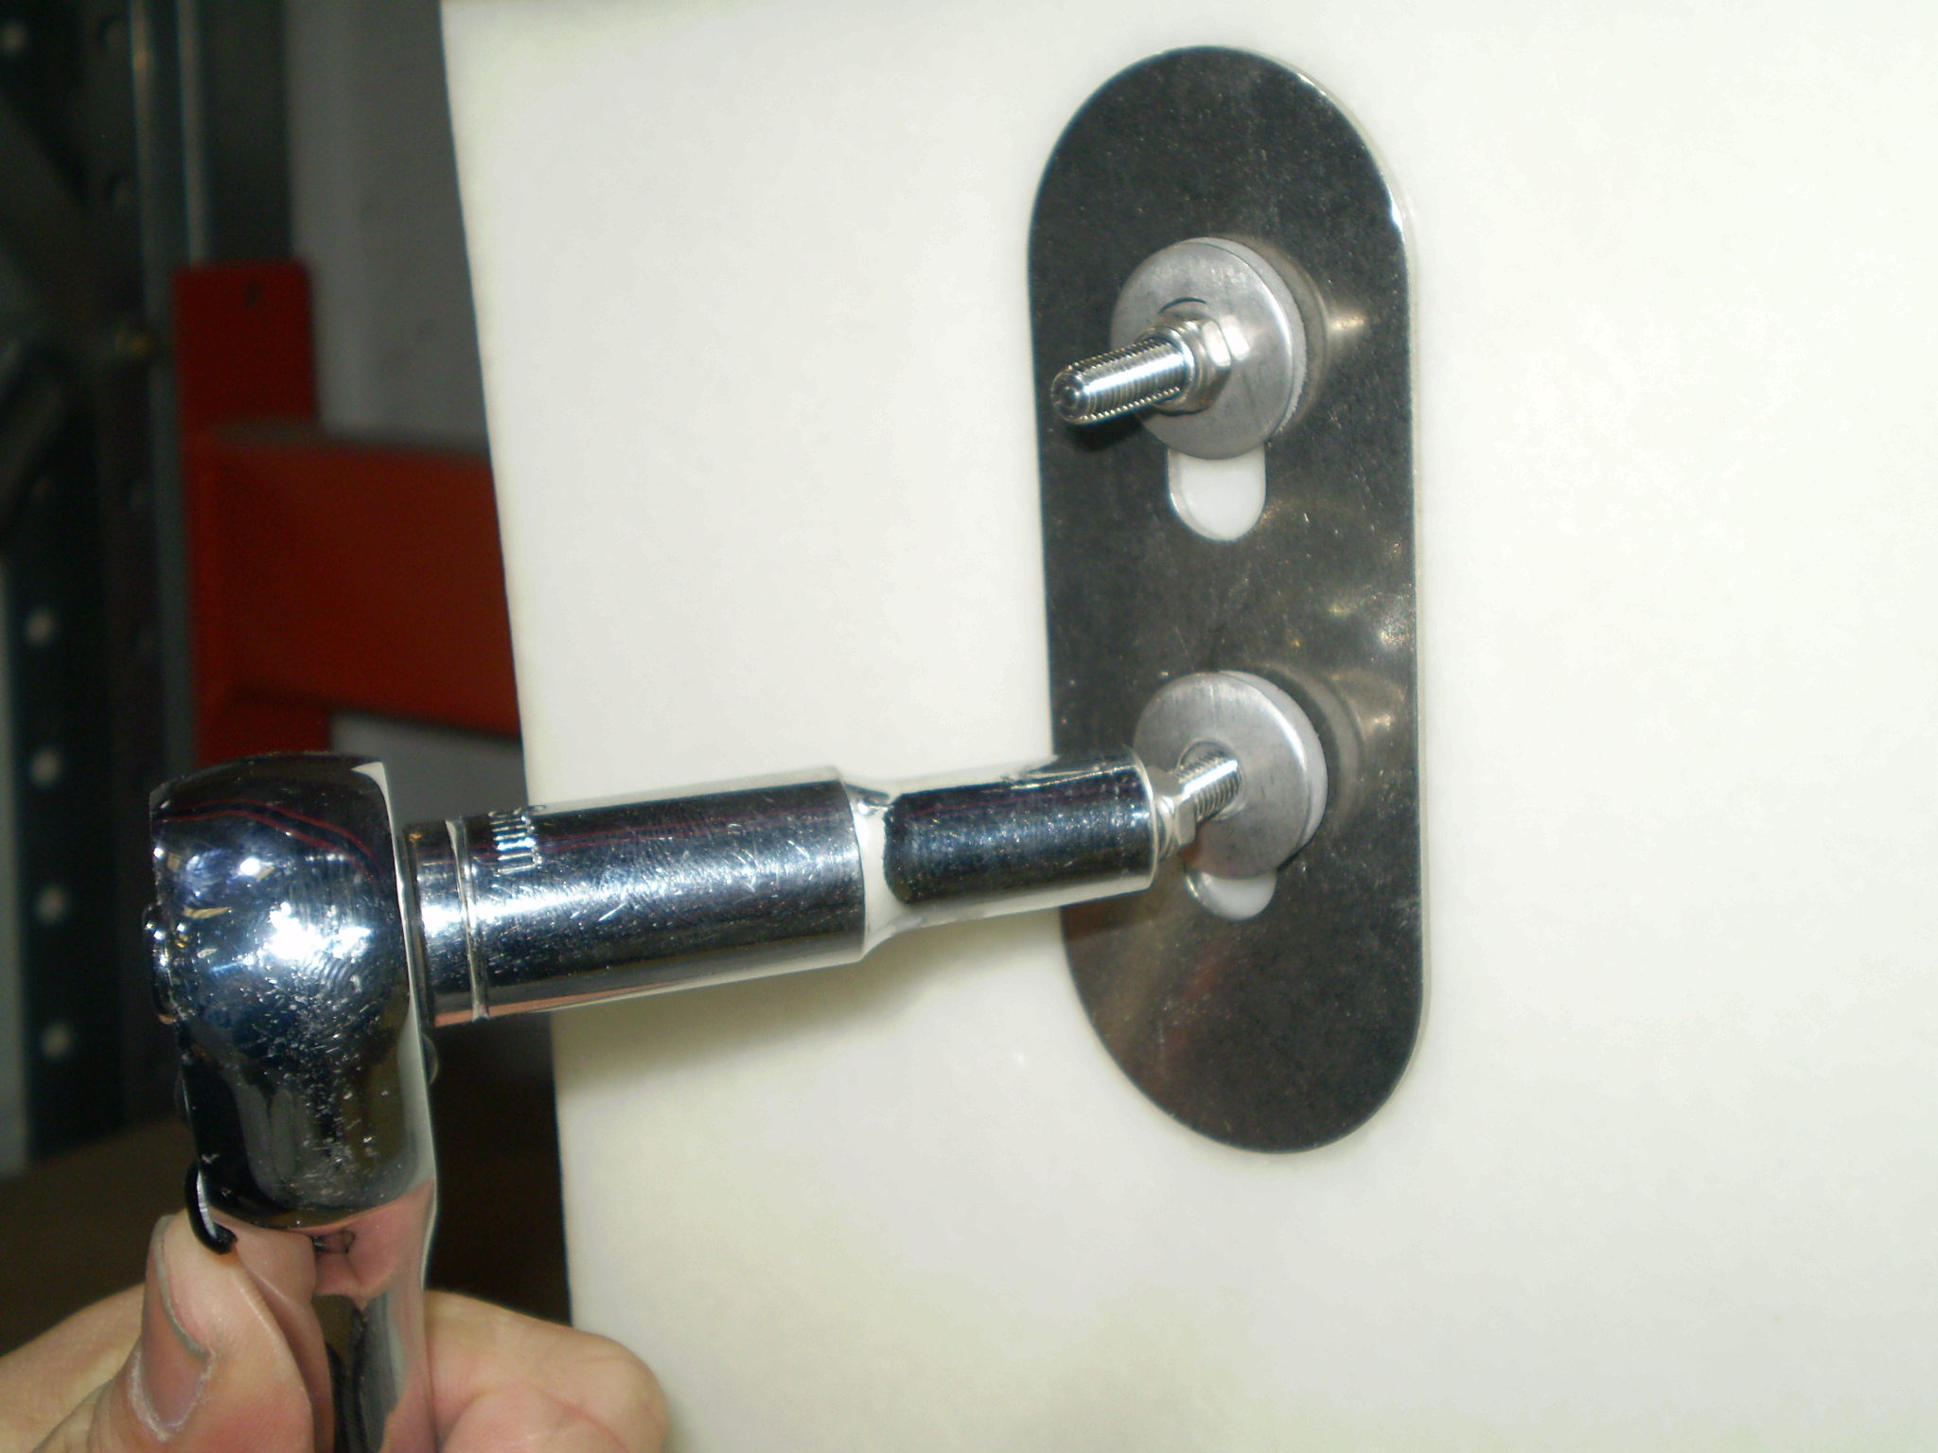
Using a small 8mm ratchet or non-ratchet spanner, tighten the two nuts so that there is no movement in the assembly but not much more.

It is important not to over tighten the nuts as the foam layer in the plastic hull will tend to start being squashed.

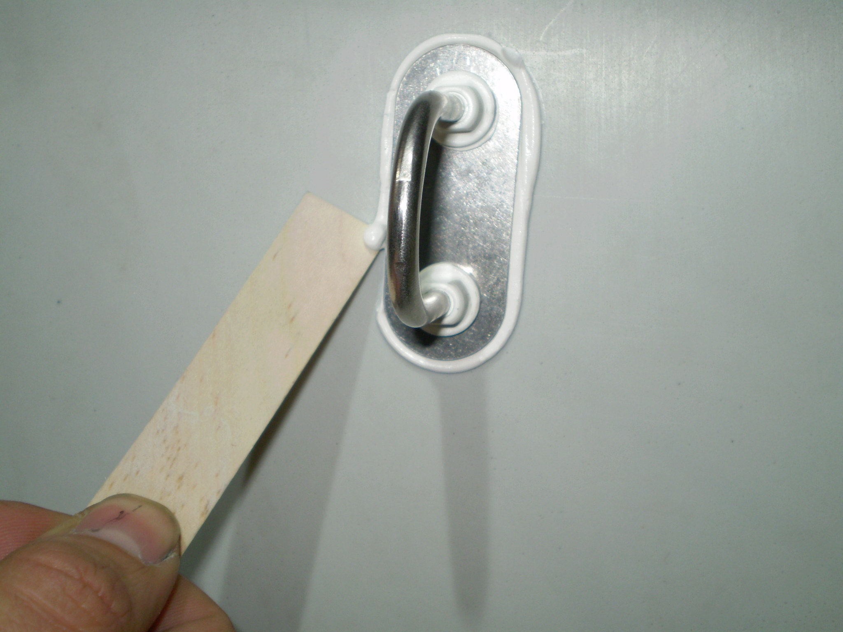

Once the nuts on the inside are tightened, the excess sealant will need to be cleaned off. You can use a wooden ‘lollypop’ style spatula with the end cut square, to scrape round the metal plate.

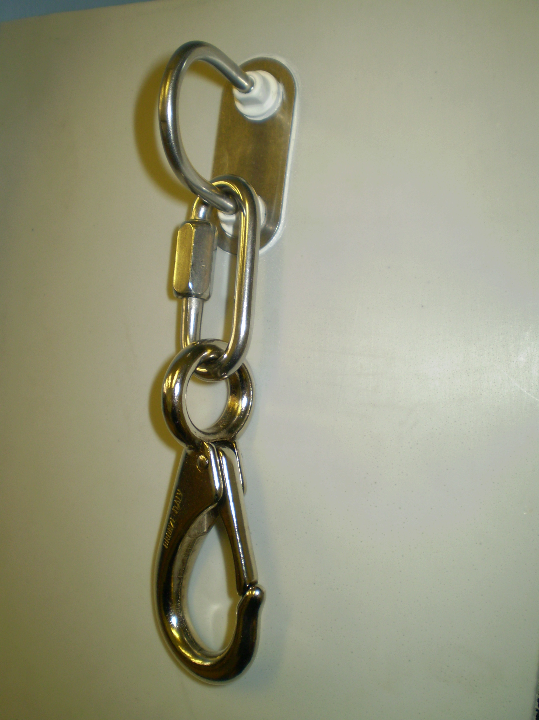

Use Acetone or similar to clean away any marks.

Tighten the rigging link with a pair of pliers and the whole assembly will be ready to use once the sealant has set (leave for at least 30 minutes).

