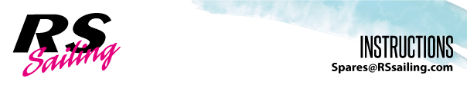
RS500 Righting Line

Kit Contains: Part Numbers:

2 x P Clips A4035

2x P Clips (Drilled to 6mm for Shroud U Bolt) A4035
2 x 6mm Dome Nuts S1
2 x M5 Nyloc Nuts F141
2 x M5 x 30mm Csk Screws F006
2 x 1.75m 8-Plait Pre-Stretched Rope (4mm) JB006
2 x 0.75m Shockcord (5mm) WHSAC415

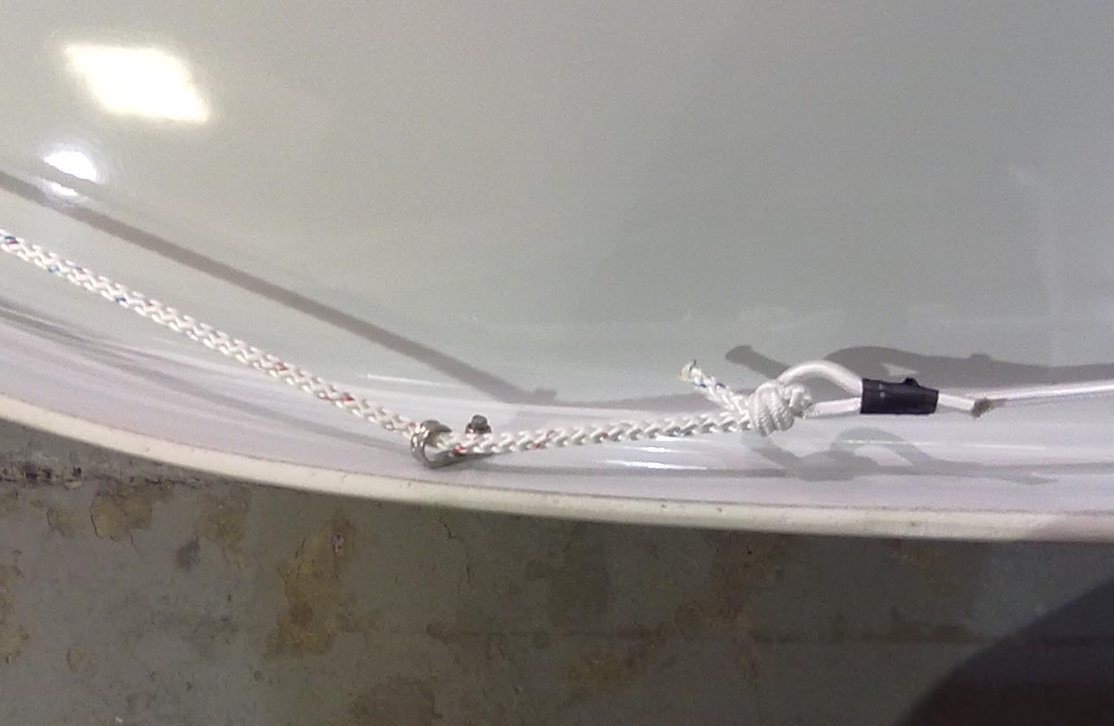
INSTRUCTIONS:
Place a P clip over the aft part of the shroud u-bolt (found under the gunwale) and fix in place using a dome nut.

Drill through the gunwale 750mm aft of the U-bolt and countersink the hole.

Using the F006 screws and the F141 nyloc nuts, fix a P clip under the gunwale.

Following the gunwale around the transom lip, drill a hole 30mm down from the deck and drill another hole a further 20mm (50mm total) down the transom lip.

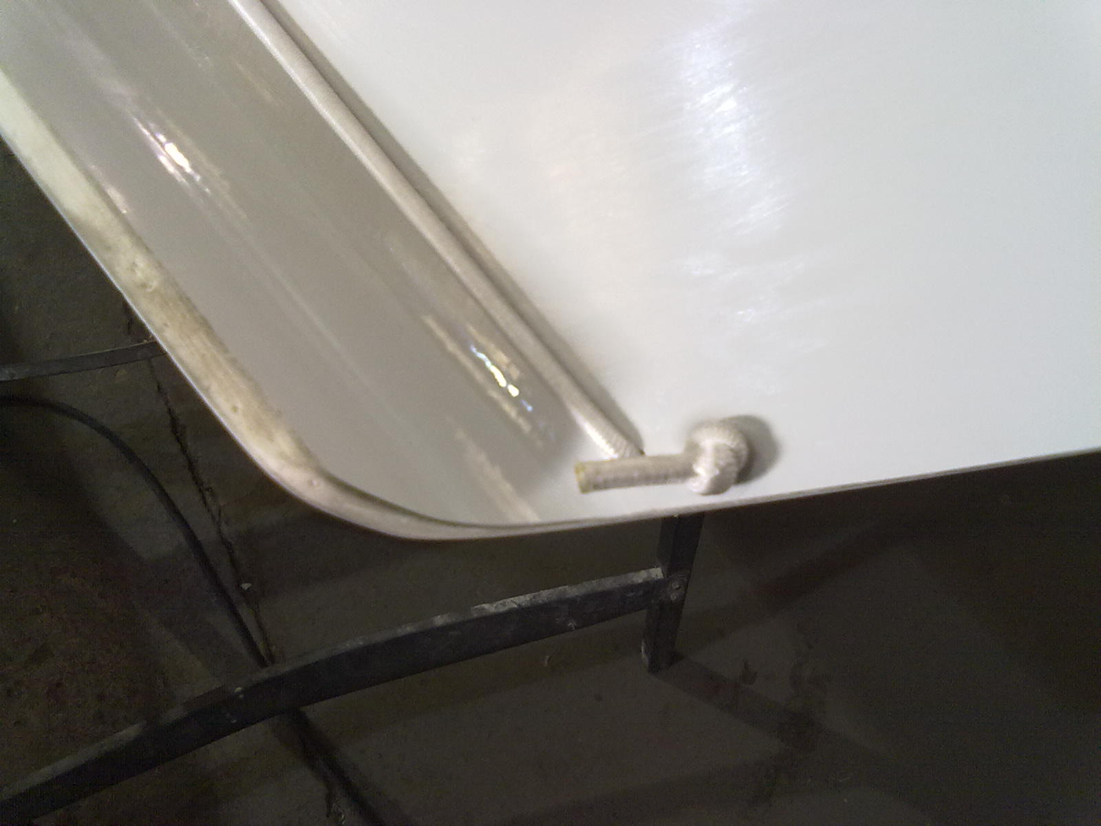
Attach the one of the pieces of rope to the P clip at the shroud U-bolt and thread the other end through the other P clip.

Looping the shockcord through the 2 holes at the transom, attach it to the free end of the rope.

Repeat for the other side.

