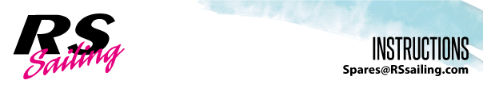
RSVareo: Righting Line

Kit Includes:

4 x P Clips HA4035
2 x 6mm Dome Nuts S1
1 x M4 Nyloc Nuts F141
1 x M4 x 25mm Csk Screws F006
2 x 1.75m 8 Plait Pre-Stretched Rope (4mm) JB006
2 x 0.75m Shockcord (5mm) WHSAC415

INSTRUCTIONS:
- Place a P clip over the aft part of the shroud U-bolt (found under the gunwale) and fix in place using a dome nut.

- Drill through the gunwale 750mm aft of the U-bolt and countersink the hole.
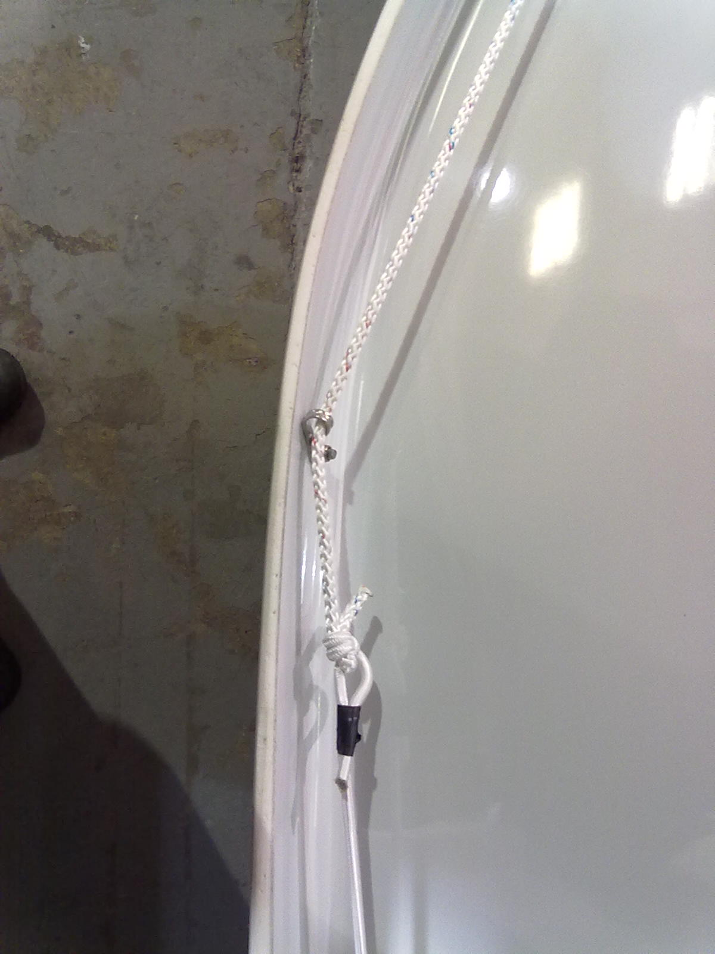
- Using the F006 screws and the F141 nyloc nuts, fix a P clip under the gunwale.

- Following the gunwale around the transom lip, drill a hole 30mm down from the deck. Drill another hole a further 20mm (50mm total) down the transom lip.

- Attach the one of the pieces of rope to the P clip at the shroud u-bolt and thread the other end through the other P clip.
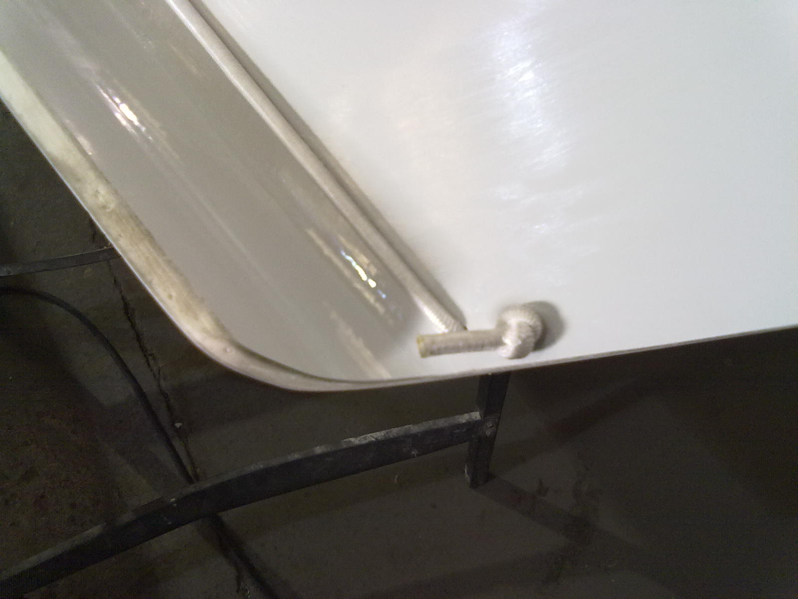

- Loop the shockcord through the 2 holes at the transom, attach it to the free end of the rope.

Follow the same procedure for the other side and you’re good to go!

