RS Feva Mast Wear Pads
These are to be fitted to all new masts once old stock has been used up, and are retro-fitable to older masts: Clean the area with a suitable solvent such as acetone and place the self adhesive pad in position.
The long pad is for the front of the mast where it is worn by the jib clew below the gooseneck (on a used mast you will see the area of wear). Position one edge against the jib or main halyard cleat and work your way across.
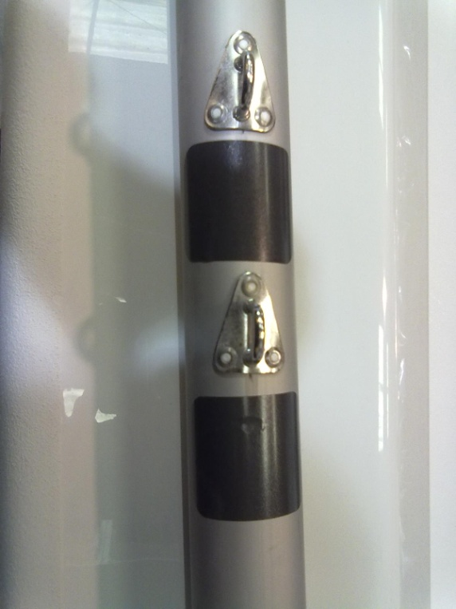
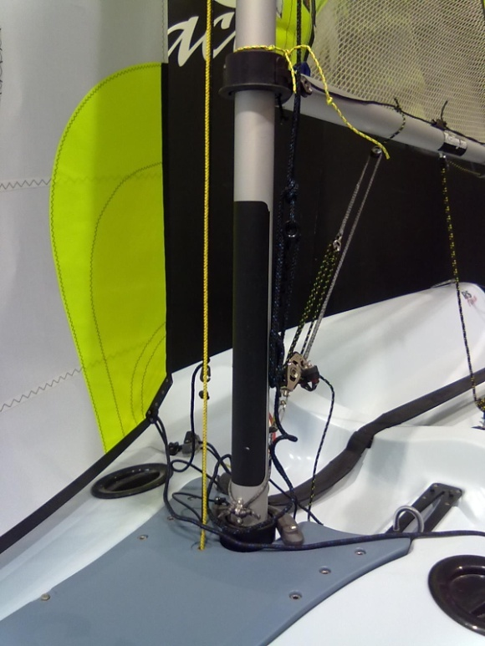

The small pads go on the front of the mast under the jib halyard block and spinnaker halyard block.

